**Lab#2**

**Random number** is a number generated for a part of set exhibiting statistical randomness. However, the random number may not be completely random on its own but the sequence of the numbers group together may introduce some randomness.

Generation of Random numbers

Random number can be generated by two methods.

i. Random number Tables

ii. Mathematical Methods.

**Congrurential method** is one of the method to generate random number in which a seed X0 is provided to generate random numbers with the following relation.

Xi+1=(aXi +b)%m

In the relation if b is zero then it is multiplicative method, if a=1 then it is additive method and if a≠1 and b≠0 then it is called mixed congruential method.

**Mid-square Random number** method is the another method to generate the random number. These random number generator are quite common in practice because of the fact that electronic devices random number generator are much more expensive.

We cannot choose a seed that guarantees that the sequences will not degenerate and will have a long period. Also zeroes onces they appear are carried in the subsequent numbers. 5197 is a bad seed and 5497 is a good seed as per the generation of the random number from the seed.

The random number which are generated are to be tested that they are consistent or not so for this purpose there are many types of test , among the **Poker Test** is one where the Chi-Square method is used to check the consistency. **Chi-Squqre($ℵ^{2})=\frac{{(o-e)}^{2}}{e}$**

**Mid-Square Method**

#include<stdio.h>

#include<conio.h>

#include<math.h>

void main()

{

float x,y,z,a;

int k,w,b;

clrscr();

printf("enter the seed\n");

scanf("%f",&x);

printf("enter the number of iteration u want to do\n");

scanf("%d",&b);

printf("\tX | Square |new X |\n");

while(b!=0)

{

y=x*x;

k=y/1000000;

z=y-k*1000000;

w=z/100;

printf("\t%.0f | %.0f | %d |\n",x,y,w);

b=b-1;

x=w;

}

getch();

}

Output:

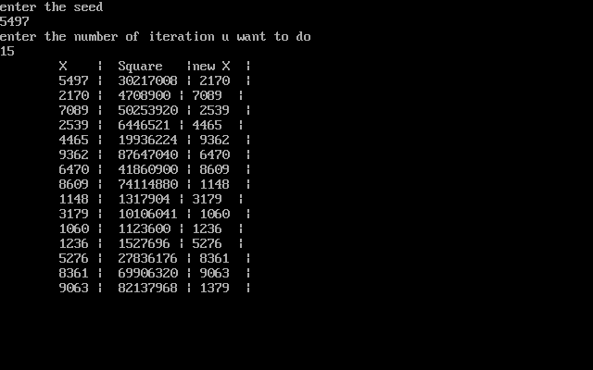

**Congruential method:**

#include<stdio.h>

#include<conio.h>

#include<math.h>

void congurential(float,float,float,float);

void main()

{

float x,a,b,m;

int n;

clrscr();

printf("enter the value of seed\n");

scanf("%f",&x);

printf("which method do u want\n1.Multiplicative\n2.additative\n3.Mixed method\n");

scanf("%d",&n);

if(n==1)

{

printf("enter the value of a,m\n");

scanf("%f%f",&a,&m);

congurential(a,x,0.0,m);

}

else if(n==2)

{

printf("enter the value of b,m\n");

scanf("%f%f",&b,&m);

congurential(1.0,x,b,m);

}

else if(n==3)

{

printf("enter the value of a,b,m\n");

scanf("%f%f%f",&a,&b,&m);

congurential(a,x,b,m);

}

else

{

printf("wrong choice\n");

}

getch();

}

void congurential(float a,float x,float b,float m)

{

int n,i,k;

float x0;

printf("how many random number do u want\n");

scanf("%d",&n);

x0=x;

printf("\t X ||\t Random Number\n");

for(i=0;i<n;i++)

{

k=((a*x0)+b)/m;

x=(a*x0)+b-k*m;

printf("\t %.2f||\t%.2f\n",x0,x);

x0=x;

}

}

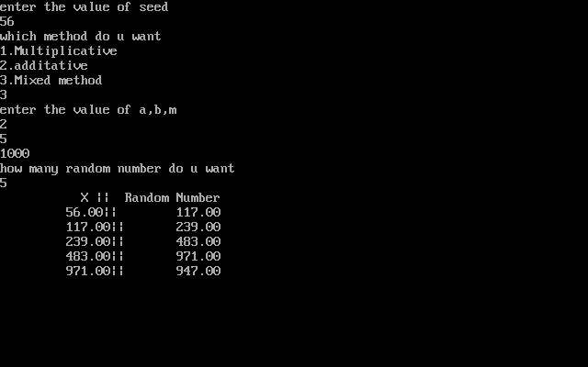Output:

**Poker test**

#include<stdio.h>

#include<conio.h>

#include<string.h>

void main()

{

float x[20],f[20],mean,e,o,chi,i,j;

int n;

char null[50],alternative[50];

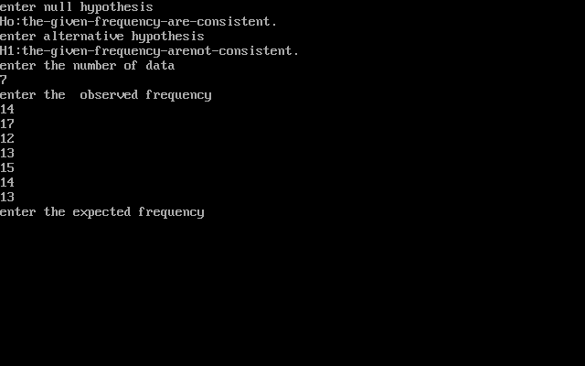clrscr();

printf("enter null hypothesis\n");

scanf("%s",&null);

printf("enter alternative hypothesis\n");

scanf("%s",&alternative);

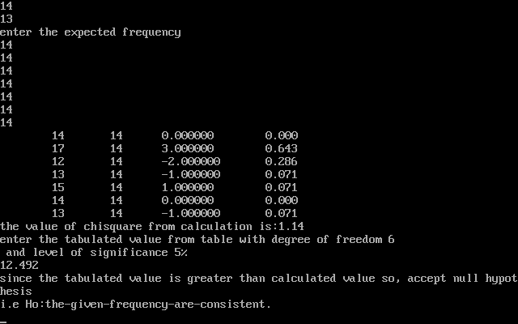printf("enter the number of data\n");

scanf("%d",&n);

printf("enter the X\n");

for(i=0;i<n;i++)

{

scanf("%f",& x[i]);

}

printf("enter the frequency\n" );

for(i=0;i<n;i++)

{

scanf("%f",& f[i]);

}

mean=0;

o=0;

for(i=0;i<n;i++)

{

o=o+x[i];

}

for(i=0;i<n;i++)

{

mean=mean+x[i]*f[i];

}

mean=mean/o;

//printf("\t no.of acc \t no.of days\n");

j=0;

for(i=0;i<n;i++)

{

printf("\t%.f \t %.f \t %f\t %.f\t%f \n", x[i],f[i],mean, x[i] *f[i],(f[i]-mean)*(f[i]-mean)/mean);

j=j+(f[i]-mean)*(f[i]-mean)/mean;

}

printf("the value of chisquare from calculation is:%.2f\n",j);

printf("enter the tabulated value from table with degree of freedom %d\n and level of significance 5%\n",n-1);

scanf("%f",&i);

if(i>j)

{

printf("since the tabulated value is greater than calculated value so, accept null hypothesis\ni.e %s\n",null);

}

else

{

printf("since the tabulated value is less than calculated value so, accept alternative hypothesis\ni.e %s\n",alternative);

}

getch();

}

Conclusion:

Hence, Lab on Random number generation was done and its consistency test method was performed in lab.